**Memo**

To: Professor Pisano

From: Nick Gutierrez, Seok Young Choi, Yumin Lisa Wei, Eunhye Kwon

Team: 24

Date: 3/30/23

Subject: Final Prototype Testing Plan

1. **Required Materials**

Hardware:

* Adafruit HUZZAH32 Esp32 Feather board
* 1 LiPoly battery
* 12 Capacitive Touch Buttons
* 2 Physical Buttons
* Adafruit MPR121 12-Key Capacitive Touch Sensor Breakout
* 3D printed Controller Casing
* 8 Color Cycling LEDs
* 1 Logarithmic Slider
* 1 Power Switch

Software:

* ESP32 code
  + Reads inputs from touch buttons and maps them to controller inputs which are then sent over Bluetooth to the computer.
* Gamepad HTML tester website
  + <https://gamepad-tester.com/>
* 1 copy of Marvel’s Spider-Man Remastered to demo in-game functionality.

**2.0 Setup**

1. Power the device by flipping the power switch.
2. Connect the device to the computer via Bluetooth
3. Press a couple of buttons to verify inputs are being registered.
4. Open the Gamepad Tester site and verify the controller is being picked up.

**3.0 Testing Procedure**

1. Demonstrate how the user’s hands should be placed and joystick mobility.
2. Demonstrate LED brightness adjustments using the slider
3. Open the Gamepad testing site and demo each button/joystick corresponding to the correct gamepad output.
4. Show control mapping in Steam’s Big Picture Mode
5. Open Spider-Man and show the controller inputs completing the corresponding action in-game
6. Swing around in Spider-Man and demonstrate movement and combat

**4.0 Measurable Criteria**

* Minimal mobility issues when using the palm joysticks and pressing the touch buttons.
* LED brightness is adjusted with the slider
* Gamepad testing site shows the correct output for controller inputs.
  + Both buttons and joysticks
* Spider-Man is demonstrated and completed.

**5.0 Esp Input to Controller Button Mapping**

| **Arduino Button** | **Controller Button** |
| --- | --- |
| Physical Button 1 (BUTTON_0) | Start |
| Physical Button 2 (BUTTON_1) | Select |
| BUTTON_2 | Left Joystick Push In |
| BUTTON_3 | Right Joystick Push In |
| BUTTON_4 | X |
| BUTTON_5 | Y |
| BUTTON_6 | LT |
| BUTTON_7 | LB |
| BUTTON_8 | RB |
| BUTTON_9 | RT |
| BUTTON_10 | A |
| BUTTON_11 | B |
| BUTTON_12 | DPad Up |
| BUTTON_13 | DPad Down |
| BUTTON_14 | DPad Left |
| BUTTON_15 | DPad Right |

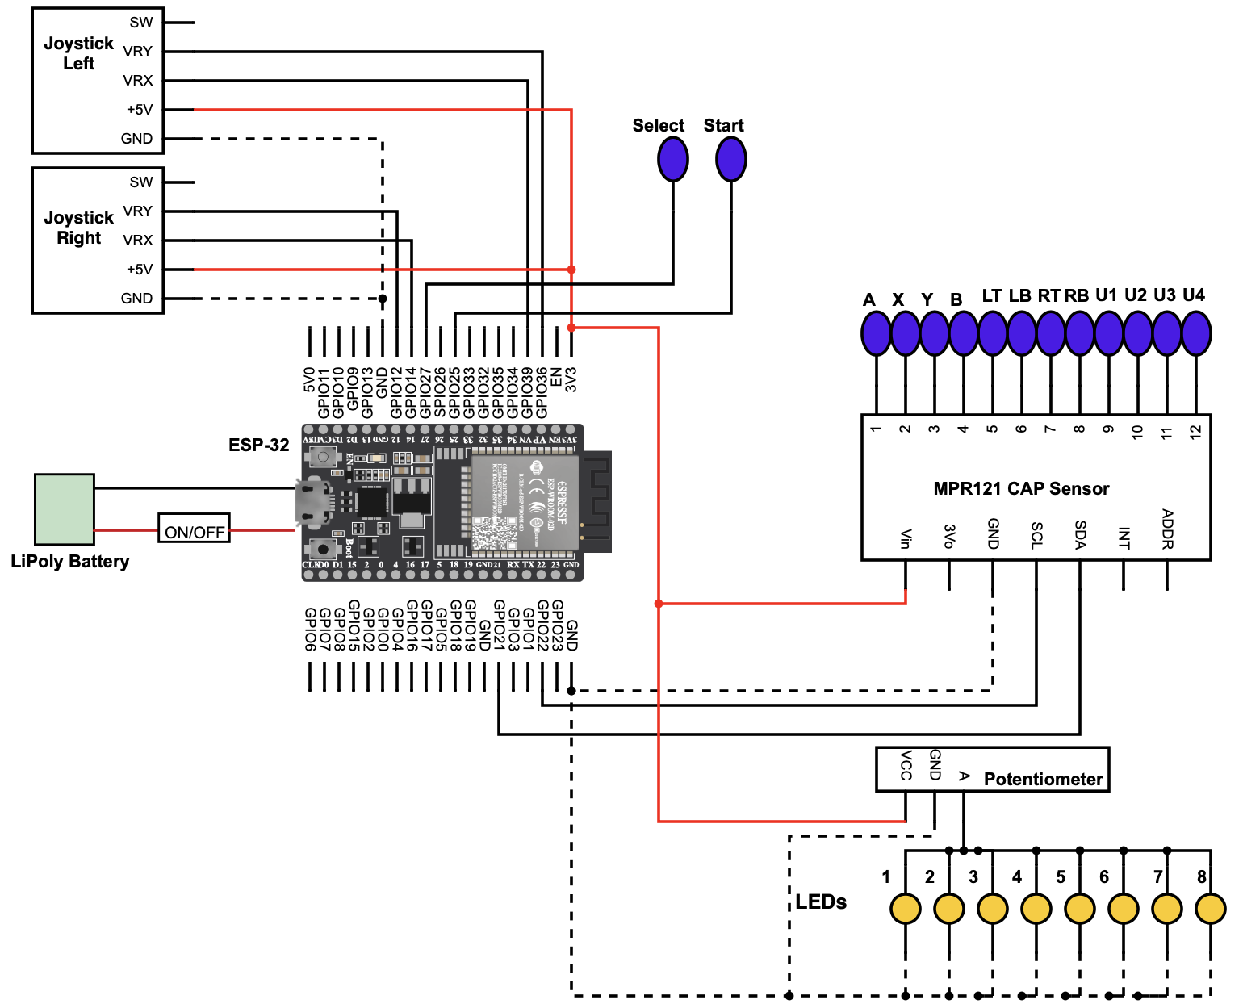

**Figure 1**: Schematic of the controller. This controller has an Adafruit HUZZAH32 Esp32 Feather, 12 touch buttons, two physical buttons, a slider, and two joysticks.

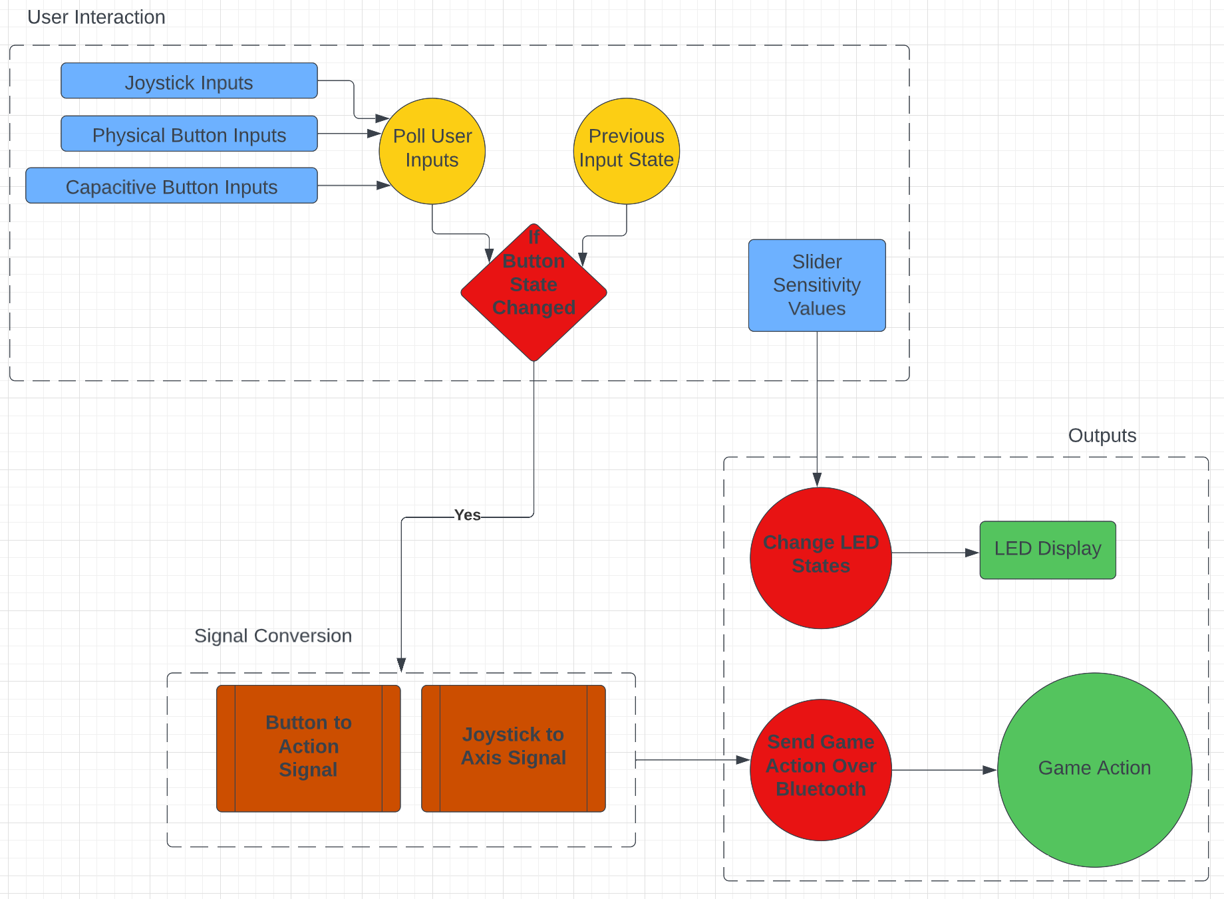

**Figure 2:** Software Flow Diagram of Controller. User Inputs are polled in a loop, converted to the proper signals, and sent to the game

**6.0 Score Sheet**

**6.1 Controller Hardware/Software Testing**

**Table 1**: Controller buttons testing results. The functionality of the buttons will be tested through gaming controller outputs, and game action performances.

| Button | Correct Controller Output? | Game Action Performed? | Button Hard to Press While Playing? | Total Score |
| --- | --- | --- | --- | --- |
| BUTTON_0 |  |  |  |  |
| BUTTON_1 |  |  |  |  |
| BUTTON_2 |  |  |  |  |
| BUTTON_3 |  |  |  |  |
| BUTTON_4 |  |  |  |  |
| BUTTON_5 |  |  |  |  |
| BUTTON_6 |  |  |  |  |
| BUTTON_7 |  |  |  |  |
| BUTTON_8 |  |  |  |  |
| BUTTON_9 |  |  |  |  |
| BUTTON_10 |  |  |  |  |
| BUTTON_11 |  |  |  |  |
| BUTTON_12 |  |  |  |  |
| BUTTON_13 |  |  |  |  |
| BUTTON_14 |  |  |  |  |
| BUTTON_15 |  |  |  |  |

**Table 2:** Joystick Testing. The functionality of the joysticks will be tested through gaming controller outputs, game action performances, and ease of use.

| Joystick | Comfortable Rest Position? | Easy to Move Around in Game? | Can Be Operated in Tandem with Other Joystick? | Total Score |
| --- | --- | --- | --- | --- |
| Left |  |  |  |  |
| Right |  |  |  |  |

**Table 3:** Other Hardware. The other pieces of Hardware need to be tested for their individual functionality (defined in the table below) and that they don’t interfere with normal gameplay (blocks buttons, sends mixed signals, etc.).

| Hardware | Functioning Properly? | Nonobstructive to Gameplay? | Total Score |
| --- | --- | --- | --- |
| Power Switch+Battery  (Powers device independent of charging cord) |  |  |  |
| LEDs  (Light up when the device is powered and cycles through colors) |  |  |  |
| Slider  (Adjusts LED Brightness) |  |  |  |